Operang Systems Fundamentals, Semester 2

4. Copy the three customer files to the archive directory using a

single command

5. Move the file leave.txt to the archive directory and rename it

leave_old.txt

6. Place leave_old.txt in the forms directory.

7. Change to the customer directory and check that it contains the

three customer files.

8. Change to the archive directory and check it contains the three

customer files that you copied.

9. Change back to the customer directory and delete the three

customer files.

10. Display the contents of the text files in the command prompt

window one at a time. (You may need to use help to find the command

do this).

11. Clear the screen

12. Exit the command prompt window

Operang Systems Fundamentals, Semester 2

4. Copy the three customer files to the archive directory using a

single command

5. Move the file leave.txt to the archive directory and rename it

leave_old.txt

6. Place leave_old.txt in the forms directory.

7. Change to the customer directory and check that it contains the

three customer files.

8. Change to the archive directory and check it contains the three

customer files that you copied.

9. Change back to the customer directory and delete the three

customer files.

10. Display the contents of the text files in the command prompt

window one at a time. (You may need to use help to find the command

do this).

11. Clear the screen

12. Exit the command prompt window

. Using the commands listed above, create the following

structure on your home directory. The Square boxes are folders,

while the lines represent folders contained inside each one. As can be

seen in the diagram below, the structure looks like a hierarchy and this

is what the use of folders provides for – a hierarchy of where data

should be saved and stored

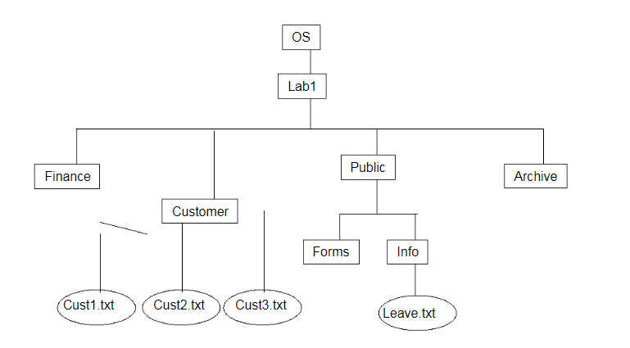

1. The commands that you need to know about to perform this part of

The lab are the following:

* mkdir
* cd
* cd ..
* mv
* cp
* ls
* cat
* clear
* exit

2. Using the commands listed above, create the following structure on your home directory. The Square boxes are folders, while the lines represent folders contained inside each one. As can be seen in the diagram below, the structure looks like a hierarchy and this is what the use of folders provides for – a hierarchy of where data should be saved and stored

3. Move the three customer files to the customer directory.

4. Copy the three customer files to the archive directory using a

single command

5. Move the file leave.txt to the archive directory and rename it

leave_old.txt

6. Place leave_old.txt in the forms directory.

7. Change to the customer directory and check that it contains the

three customer files.

8. Change to the archive directory and check it contains the three

customer files that you copied.

9. Change back to the customer directory and delete the three

customer files.

10. Display the contents of the text files in the command prompt.

11. Clear the screen

12. Exit the terminal session

**Submission:**

Take screenshots of your terminal showing each command executed successfully and submit them.